What did Educating for Peace accomplish last year?

Educating for Peace Student Leadership Program engages students to apply for the Harold Schnitzer Spirit of Unity grant and to start their own school-based peace project or club. We have stimulated the beginning of more than 70 clubs in Oregon and Southwest Washington, allowing every student an opportunity to be acknowledged for their exemplary moral courage and actions toward achieving a more peaceful world. We had excellent feedback from community members and students regarding this program. We were asked to continue and expand the program to more schools in Oregon. Last year ten peace clubs were selected and one peace educator of the year was honored at a Student Peace Summit held at Baker Prairie Middle School in Canby with featured speaker and author Dr. Robert Miller.

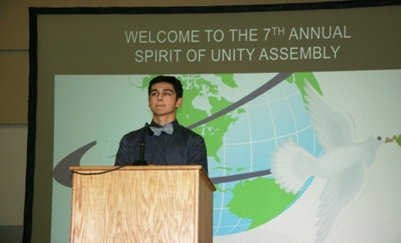
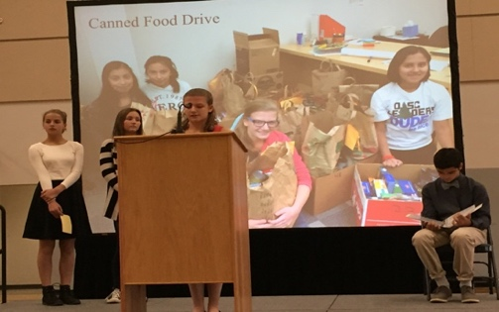
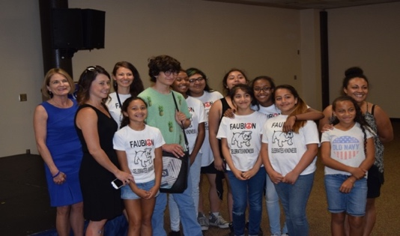

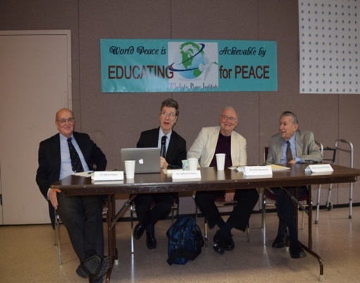
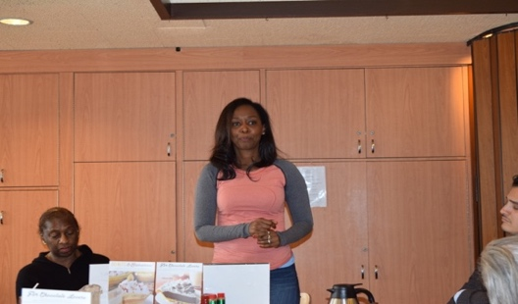
Community Peace Events take place every month and feature a different peace speaker. We use this time to expound on all variety of issues, multi-cultural, morality, education, interfaith, war prevention, etc. and find ways to dialogue on issues that may be pressing in our communities or controversial, intolerable, or incomprehensible. Our luncheons are a great forum for speakers, bloggers, adventurers to share their knowledge and experience that helps raise awareness for our members and supporters. All opinions and ideas are welcome. Below are pictures from three memorable events in 2015.

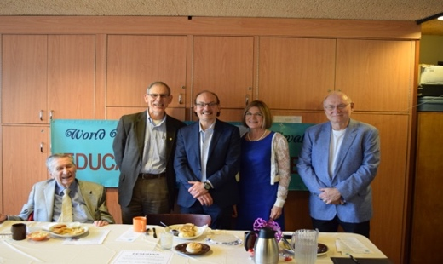

Immaculée Ilibagiza is a Rwandan author “Left to Tell” and motivational speaker, who was featured on PBS and also on 60 Minutes. She speaks about her experience during the 1994 Rwandan genocide. She survived hidden for 91 days with seven other women in a small bathroom, no larger than 3 feet long and 4 feet wide with an area of 12 feet. During the genocide, most of Ilibagiza’s family was killed by Hutu Interahamwe soldiers: her mother, her father, and her two brothers Damascene and Vianney. Besides herself, the only other survivor in her family was her brother Aimable, who was studying out of the country in Senegal and did not know the trauma his sister survived.

Dr. Jeffrey Sachs is the director of the UN Sustainable Development Solutions Network Network and Special Advisor to United Nations Secretary-General Ban Ki-moon on the Sustainable Development Goals, having held the same position under former UN Secretary-General Kofi Annan. He has authored three New York Times bestsellers in the past seven years. Dr. Sachs is the Director of The Earth Institute, Quetelet Professor of Sustainable Development, and Professor of Health Policy and Management at Columbia University.

Like us on Facebook to keep updated or visit our website: www.wholisticpeaceinstitute.com
Neal Keny-Guyer is a social entrepreneur committed to creating a more just and peaceful world. Keny-Guyer joined Mercy Corps in 1994 as Chief Executive Officer. Under his aegis, Mercy Corps has emerged as a leading international humanitarian and development organization with ongoing operations in more than 40 countries, a staff of 5,000, and global revenue of $437 million. Keny-Guyer has forged new directions at Mercy Corps, most notably implementing global mergers and strategic alliances, placing human rights, civil society and social entrepreneurship at the forefront of Mercy Corps humanitarian mission, and building an organizational reputation for groundbreaking, innovative programming in the world’s toughest environments.

What are we doing now?

EDUCATING FOR PEACE ANNOUNCES THE 2016 AND 2017 NOBEL PEACE LAUREATE SPEAKER SERIES
MEET AND HEAR OUR CONTEMPORARY ARCHITECTS OF WORLD PEACE

We need your help to cultivate a culture of peace in our school system.

Just sitting down with a child and explaining the important of peace is not enough. It’s already a complicated concept to explain, made more difficult by the amount of violence and conflict they’re exposed to not just from catching snippets of TV news, but by sitcoms, cartoons, video games, and toys. Yet the road to a more peaceful future lies in the hands of children which, as adults can change the world. Help Educating for Peace further our Student Peace Leadership Program, creating more student led peace clubs in schools across Oregon. The students will have an opportunity to meet one or more of the world renowned Nobel Peace Prize winners

Educating for Peace the Wholistic Peace Institute brings Nobel Peace Laureates together with northwest students, communities, and faculty to inspire, educate and transform our world. The Institute’s work with Nobel Peace Prizewinners is our flagship program. We believe that these men and women and organizations that receive the prestigious Nobel Peace Prize are the “architects of global peace” and we have hosted 12 Nobel Peace Laureates here in Oregon and visited and participated in Nobel Peace Summits throughout the world. If the wisdom of these courageous, yet sometimes quite simple and humble peacemakers could be more available to the young, we are convinced that the world’s conflicts would be less and that our mission would be furthered. Which is why we ask you to support our Nobel Peace Laureate Program?

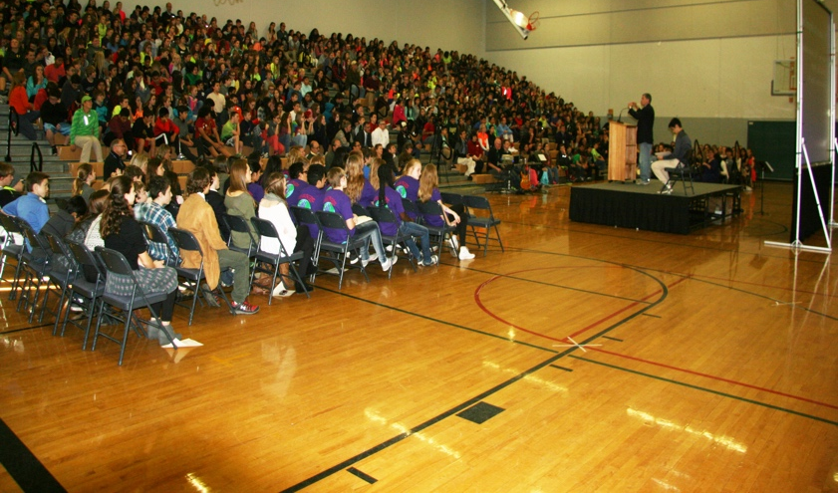
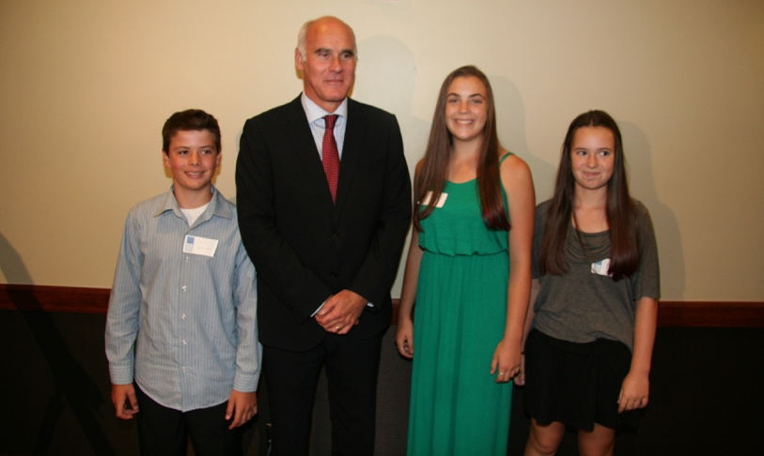

Through the Nobel Peace Laureate Program, we have outlined and executed seven memorandums of understanding and seven Mayoral proclamations of Peace for issues as important and diverse as ending nuclear proliferation, banning land mines, reducing epidemics of disease and child mortality, finding a peaceful resolution to the war between North and South Korea. We ask you to support our peace education work around the country by becoming a member of Educating for Peace – Wholistic Peace Institute

