INVITATION TO AUTUMN EQUINOX CELEBRATION - COME AND PRAY FOR WORLD PEACE AND THE EARTH
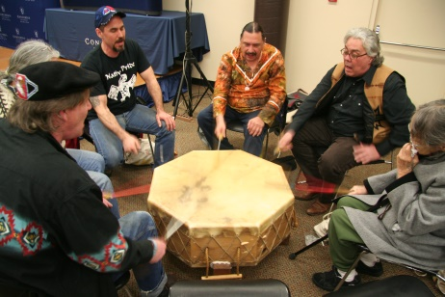

Saturday, September 23, 2017
10am to Noon – With Potluck Lunch Following
A Turkey Will Be Cooked – Please Bring Side Dishes
All Ages Welcome

Ceremony Led by Max Defender, Ojibwe Elder from the Turtle Mountain Reservation in North Dakota; Miguel Medina of Singing Tree Flutes https://www.singingtreeflutes.com/ and Gary Alan Spanovich – www.garyalanspanovich.com of the Church of the Still Small Voice

Please Bring Your Prayers – Drum – Rattle – Singing Bowl – Or Other Instruments for the “Healing Drum Ceremony”

Equinox
We will celebrate the Fall Equinox - It refers to the time that occurs only twice a year when the nighttime is equal to the daytime; each being nominally 12 hours in duration.

For More Information Gary at 503-314-5955 or Nancy at 503-701-9987 or garyalanspanovich@gmail.com

