BRINGING OUR HUMAN FAMILY TOGETHER FOR PEACE
Tentative PROGRAM - DR. AZIZ SADAT - Director of Afghanistan Public Affairs Council & Former Official to Past Presidents and Vice Presidents
Contact: kabul8.2021@gmail.com Phone: 1(219)331-9044

- Saturday – Dr. Aziz Sadat, Arrival from DC

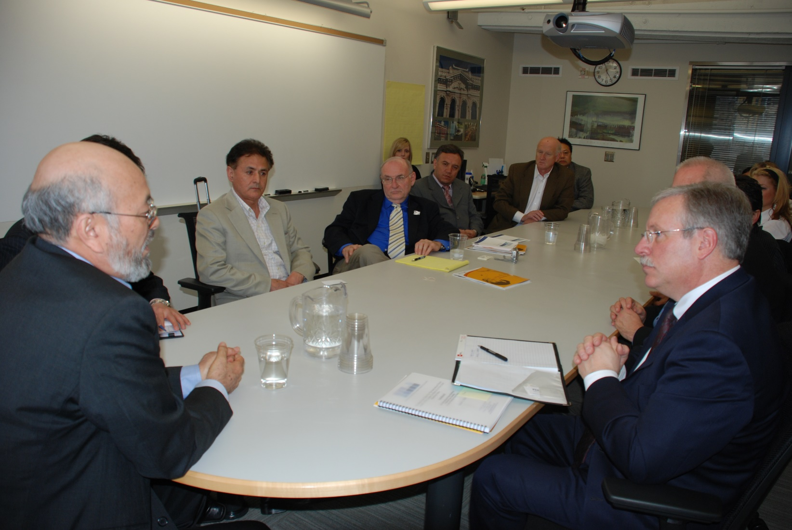
Vice President Khalili; next to him Azia; then Gary Spanovich; Bruce Warner head of PDC to the Vice Presidents right; other Oregon State officials


Sunday – Lecture at Our Lady of the Lake Catholic Parish After masses; Lunch or dinner with Fr John Kerns

- Monday - Lectures & Lunch – PSU; Professor Harry Anastasiou to host; and https://www.pdx.edu/alumni/news/afghan-family-legacy-education-gift-lifetime

- Tuesday - Oregon Afghan Network (300+ members): Day Meetings; Gala Dinner
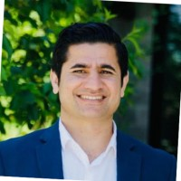
- Darwish Zakhil
Cofounder and Director at Afghan support Network

- Wednesday – Other University

- Thursday – Jubitz Foundation; Other Non Profits
- Friday – PDC; State of Oregon; Potential Governor

- Saturday – Dr. Aziz Sadat, Return to DC; he is planning a July trip Afghanistan for peace

POTENTIAL LECTURE & TRAINING TOPICS:
- Politics played a role and failed in Afghanistan;
- What worked and what did not work;
- How the Taliban formed their government;
- Proposed new Afghan peace process; July trip to Afghanistan led by Dr. Aziz Sadat
- Trainings using the Wholistic Approach

EDUCATING FOR PEACE WILL BE HOSTING DR. AZIZ SADAT
DR. AZIZ SADAT - Director of Afghanistan Public Affairs Council
Contact: kabul8.2021@gmail.com Phone: 1(219)331-9044
Dr. Aziz Sadat is the Afghanistan Public Affairs Council (APAC) director in Washington, DC. In addition to this significant role, he is distinguished by his position as a senior special advisor to other Peace Foundations, which is also based in Washington, DC. Sadat's academic and professional endeavors primarily concentrate on conducting comprehensive research and engaging in extensive outreach activities. These activities are centered around the nuanced themes of conflict, fragility, and the developmental trajectory of Afghanistan, with a particular emphasis on competition dynamics, safeguarding Human Rights, and promoting Education.
Within his expertise, Sadat delves deeply into understanding the primary drivers that precipitate armed conflict and instability within Afghanistan. His scholarly pursuits extend to formulating and implementing strategic responses to mitigate conflict and enhance security measures. Beyond the national scope, Sadat addresses global challenges that include, but are not limited to, the issue of forced migration, presenting a multifaceted perspective on the subject.
A testament to his commitment and involvement in fostering Afghan peace, foreign relations, and the resurgence of Afghan civilization, Sadat’s engagement traces back to the era following the Russian invasion of 1979. His profound contributions over the years encompass the development of innovative approaches dedicated to conflict prevention, post-conflict resolution, and advancing peacebuilding policies. Notably, in 1995, during the oppressive regime of the Taliban, Sadat was jailed as a political prisoner. Yet, he emerged to be appointed as the ambassador to China, reflecting his resilience and unwavering dedication to peace and diplomacy.
Before his affiliation with the Afghanistan Public Affairs Council, Sadat contributed a decade of service as a full-time consultant to the Afghan government. His focus was predominantly on addressing fragility, conflict, and forced displacement. His role entailed spearheading research initiatives, shaping policymaking processes, authoring seminal publications, and fostering policy dialogues with governmental bodies. Additionally, Sadat orchestrated partnerships with various actors, including bilateral, multilateral, national, and local stakeholders, and executed capacity-building and educational programs.
In a landmark initiative, Aziz Sadat orchestrated the coordination of the Afghan president's particular representative office, Pathways for Peace: Inclusive Approaches to Preventing Violent Conflict. This initiative was pivotal in establishing the Ministry of Peace, marking a significant shift towards prioritizing development and facilitating peace negotiations between the Afghan government and the Taliban.
Sadat’s career trajectory is marked by his leadership roles, including serving as the Director of International Relations and Senior Adviser to the Ministry of Urban Development and Land and holding similar positions within the President’s Special Representative Office for National Solidarity and Reforms and Good Governance.
As a visionary leader, Sadat has been the founding force behind establishing the Afghanistan Ministry of Peace, the Afghanistan National Institute for Peace and Justice, and the World Trade Center of Kabul.
Aziz Sadat is academically credentialed with a Ph.D. (Horn) in International Relations and Economics, having pursued his education at the prestigious University of Washington and Lower Columbia College, located in Washington. His educational background and professional experiences synergize to position him as a pivotal figure in international relations, peacebuilding, and developmental policy concerning Afghanistan and beyond.

